DBMS ASSIGNMENT-2

Question 1.:-Create the following tables and specify constraints at the time of creation.

DEPARTMENT:-

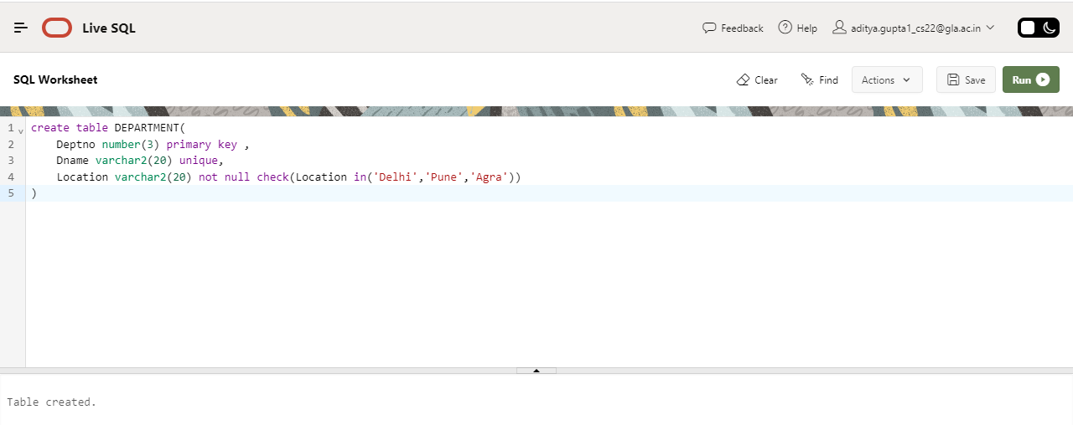

EMPLOYEE:-

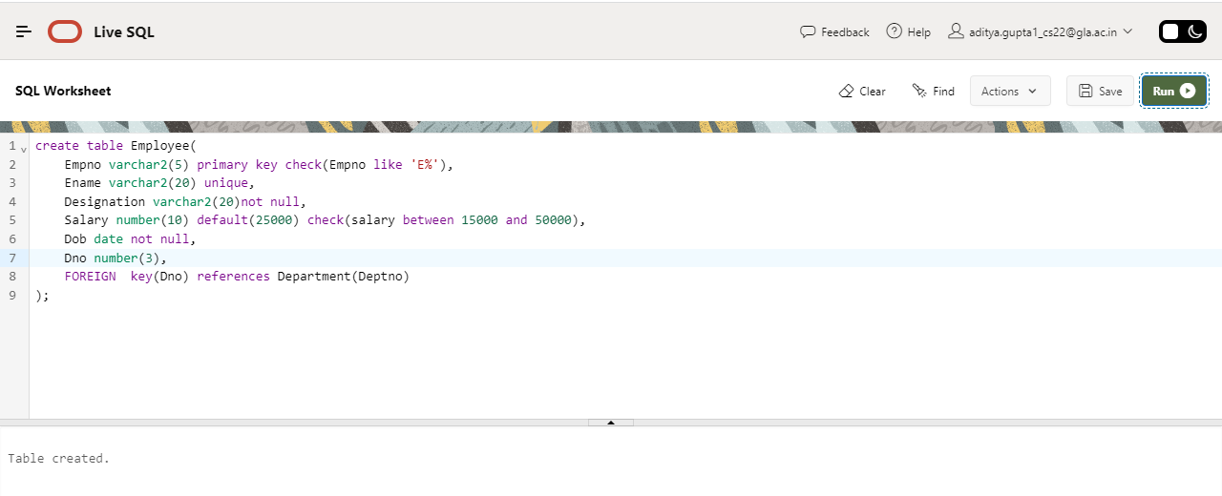

CANDIDATE:-

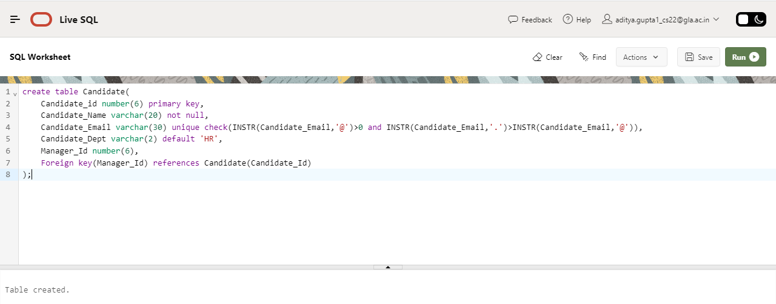

Question 2:-Create the schemas as specified above without specifying any constraints.

COLLEGE:-

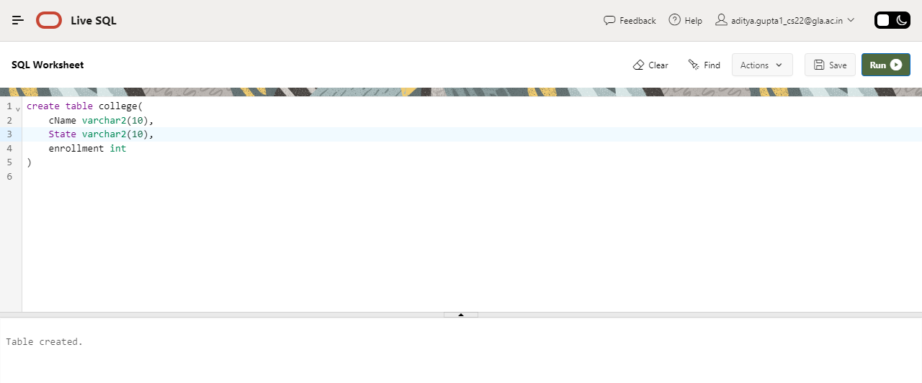

STUDENT:-

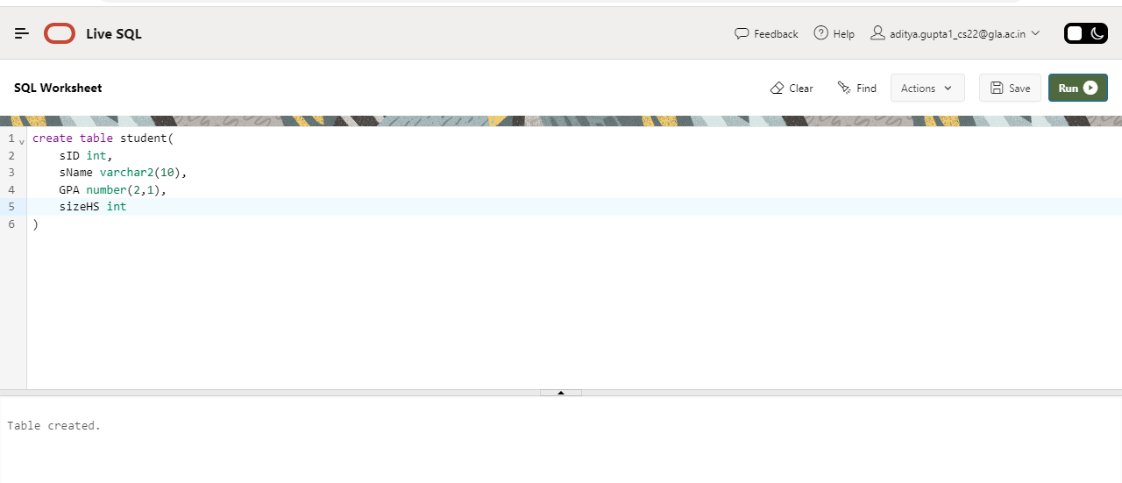

APPLY:-

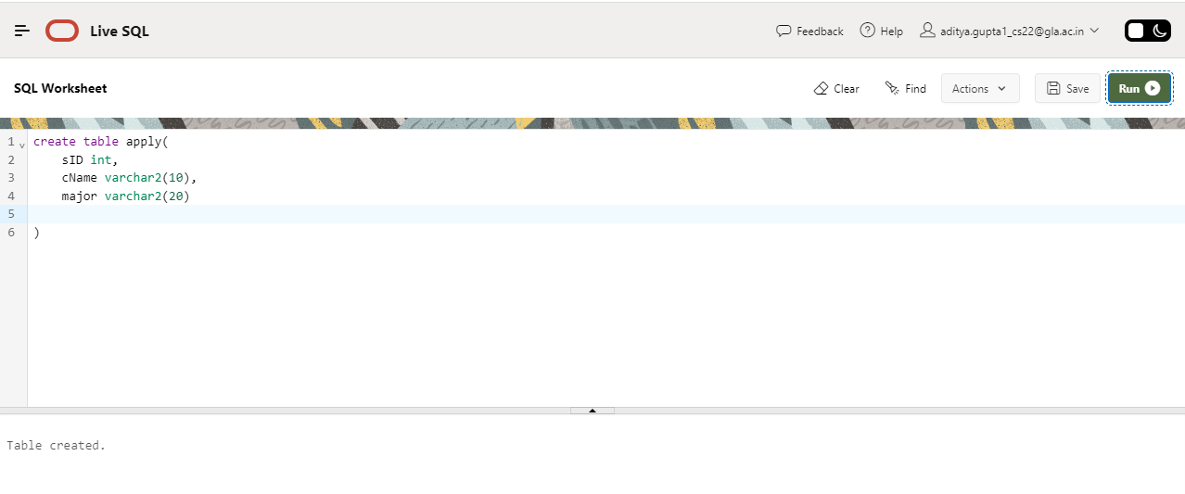

1. Add **cName** as **Primary key** in **College**.

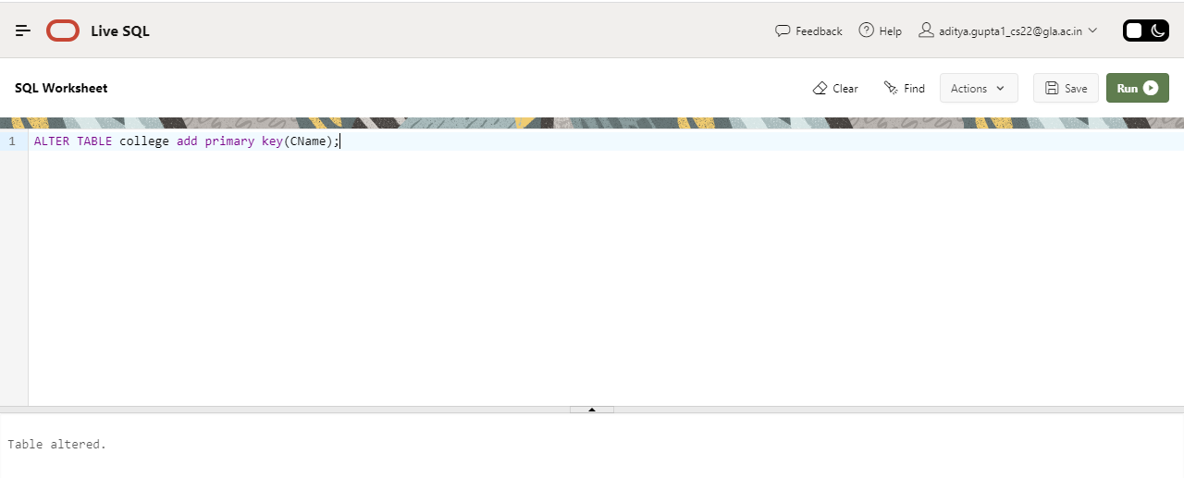

1. Add **sID** as **Primary key** in **Student**.

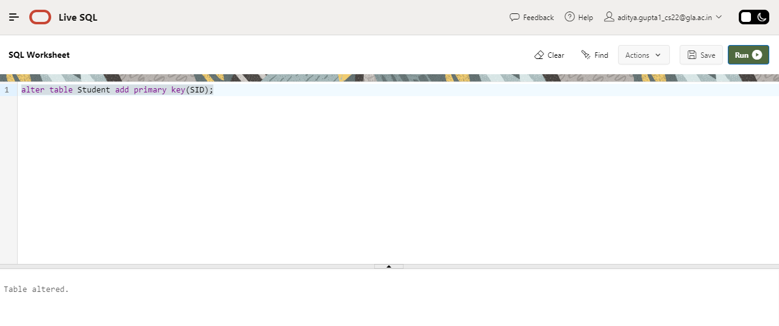

1. Add **sID**, **cName**, **major** as **Primary key** in **Apply**.

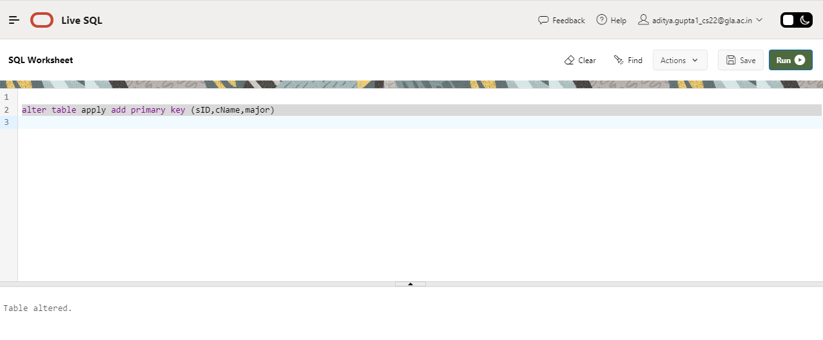

1. Make **sID** in **Apply foreign key** referring table **student** and **cName** referring table **college**.

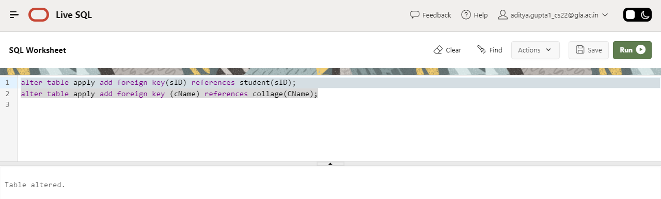

5.Increase data type size of **major** from 20 to **25**.

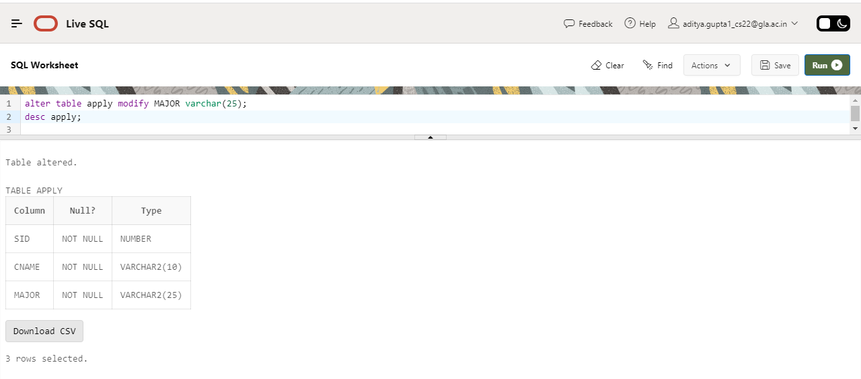

6.Add a new column **decision** in the **Apply** table keeping a constraint of **not null** for this column with data type **varchar2(3)**.

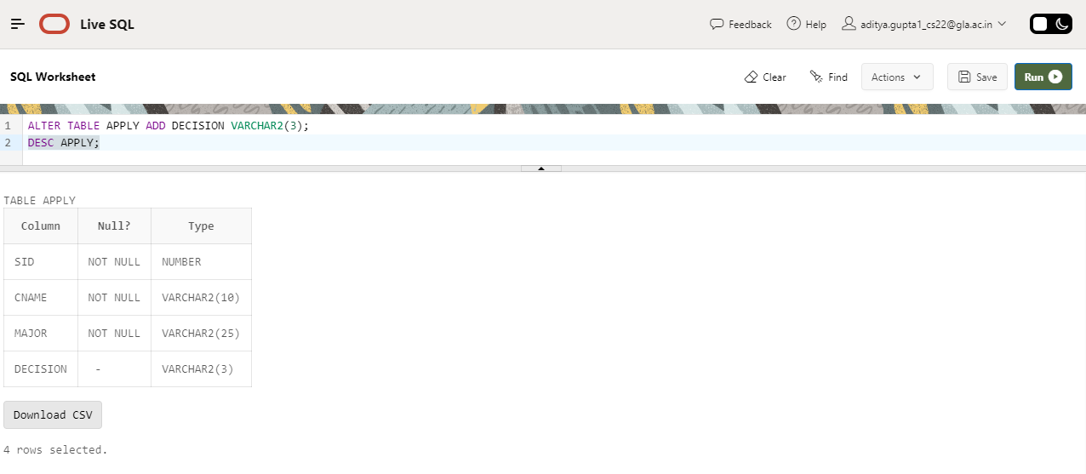

7. Change data type of **decision** in **Apply** to **char(1).**

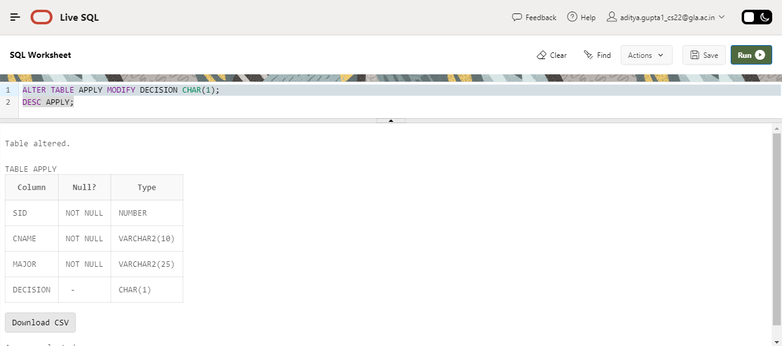

9. Remove column **sizeHS** from **Student** table.

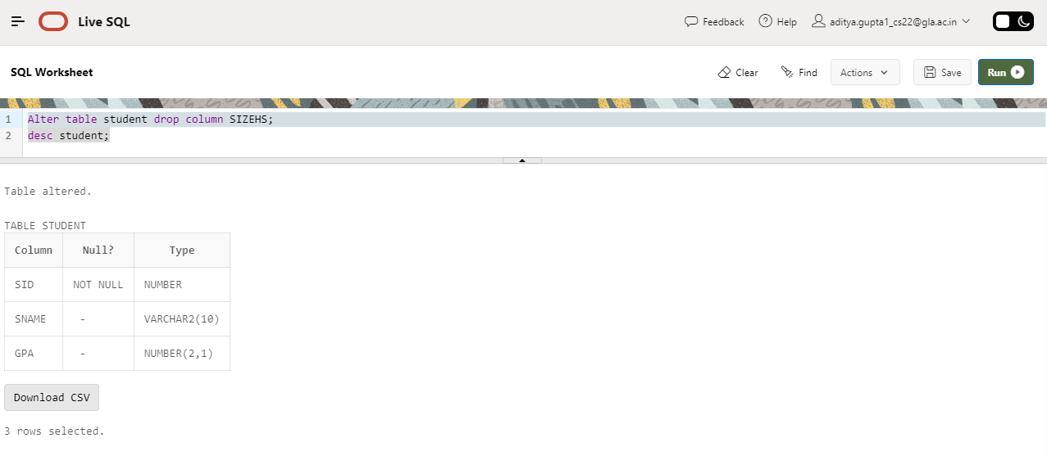

10. Drop **primary key** from College .

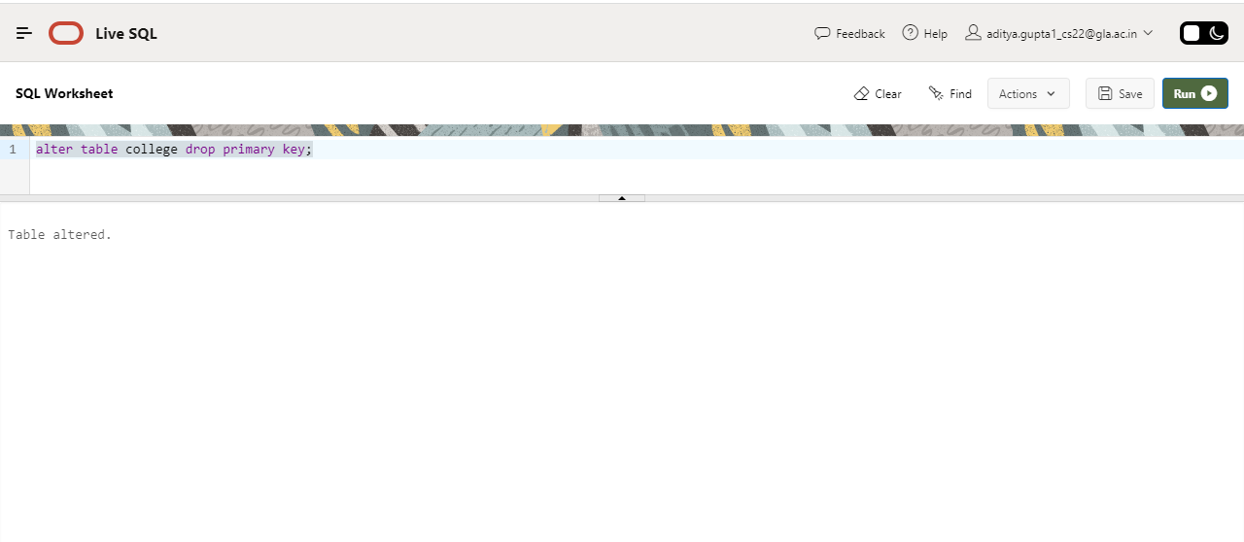

11. Make **cName, major** unique pairwise such as Stanford CS, Stanford EE.

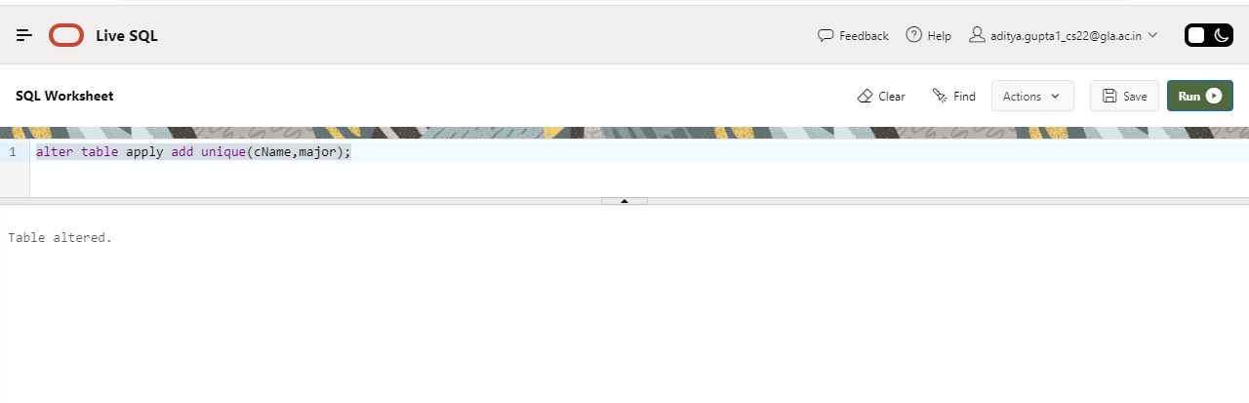

14. Rename column **enrollment** to **enroll** in College Table.

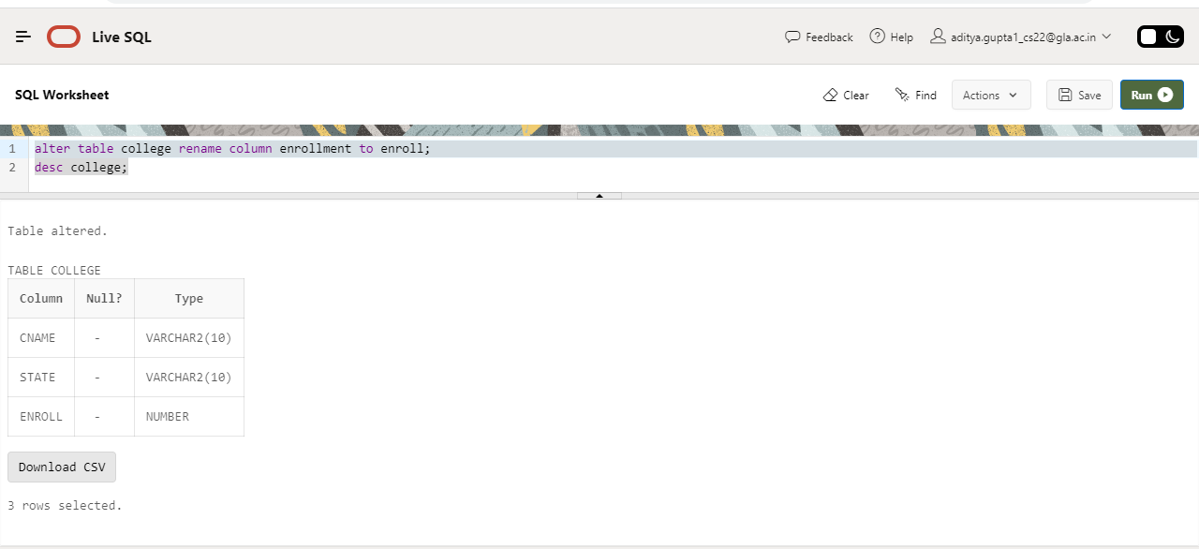

NAME 🡪 ADITYA GUPTA

SECTION 🡪 B

UNIV ROLLNO. 🡪 2215000094

CLASS ROLLNO. 🡪47